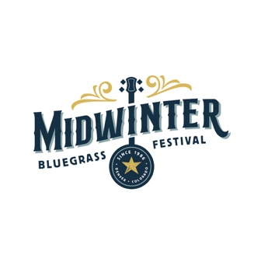

Midwinter Bluegrass Festival

Early Bird Pricing Order Form
February 13-15, 2026
Delta by Marriott (formerly the Radisson)
10 E 120th Ave, Northglenn, CO 80233

NAME:

ADDRESS:

EMAIL: ________________________________________________

Ticket | Cost | How Many? | Subtotal
3 Day Early Bird | $110 + 4% tax = $114.40
Fri/Sat 2 Day Early Bird | $95 + 4% tax = $98.80
Sat/Sun 2 Day Early Bird | $100 + 4% tax = $104.00
Friday Only Early Bird | $60 + 4% tax = $62.40
Saturday Only Early Bird | $90 + 4% tax = $93.60
Sunday Only Early Bird | $75 + 4% tax = $78.00
3 Day, Child 6-12 | $65 + 4% tax = $67.60
Fri/Sat 2 Day, Child 6-12 | $30 + 4% tax = $31.20
Sat/Sun 2 Day, Child 6-12 | $40 + 4% tax = $41.60
Friday, Child 6-12 | $25 + 4% tax = $26.00
Saturday, Child 6-12 | $25 + 4% tax = $26.00
Sunday, Child 6-12 | $25 + 4% tax = $26.00
 | Totals:

We lowered base prices from 2025 and are now collecting the Northglenn sales tax upfront.
Tickets will be emailed for your wristbands, please make sure your email is included and legible above.

NOTE: Your form and check MUST be postmarked by Dec 31, 2025 for early bird prices to be honored, otherwise your check will be returned

Mail form and check to:
Ryegrass Productions, LLC
1332 N Cascade Ave
Colorado Springs, CO 80903

